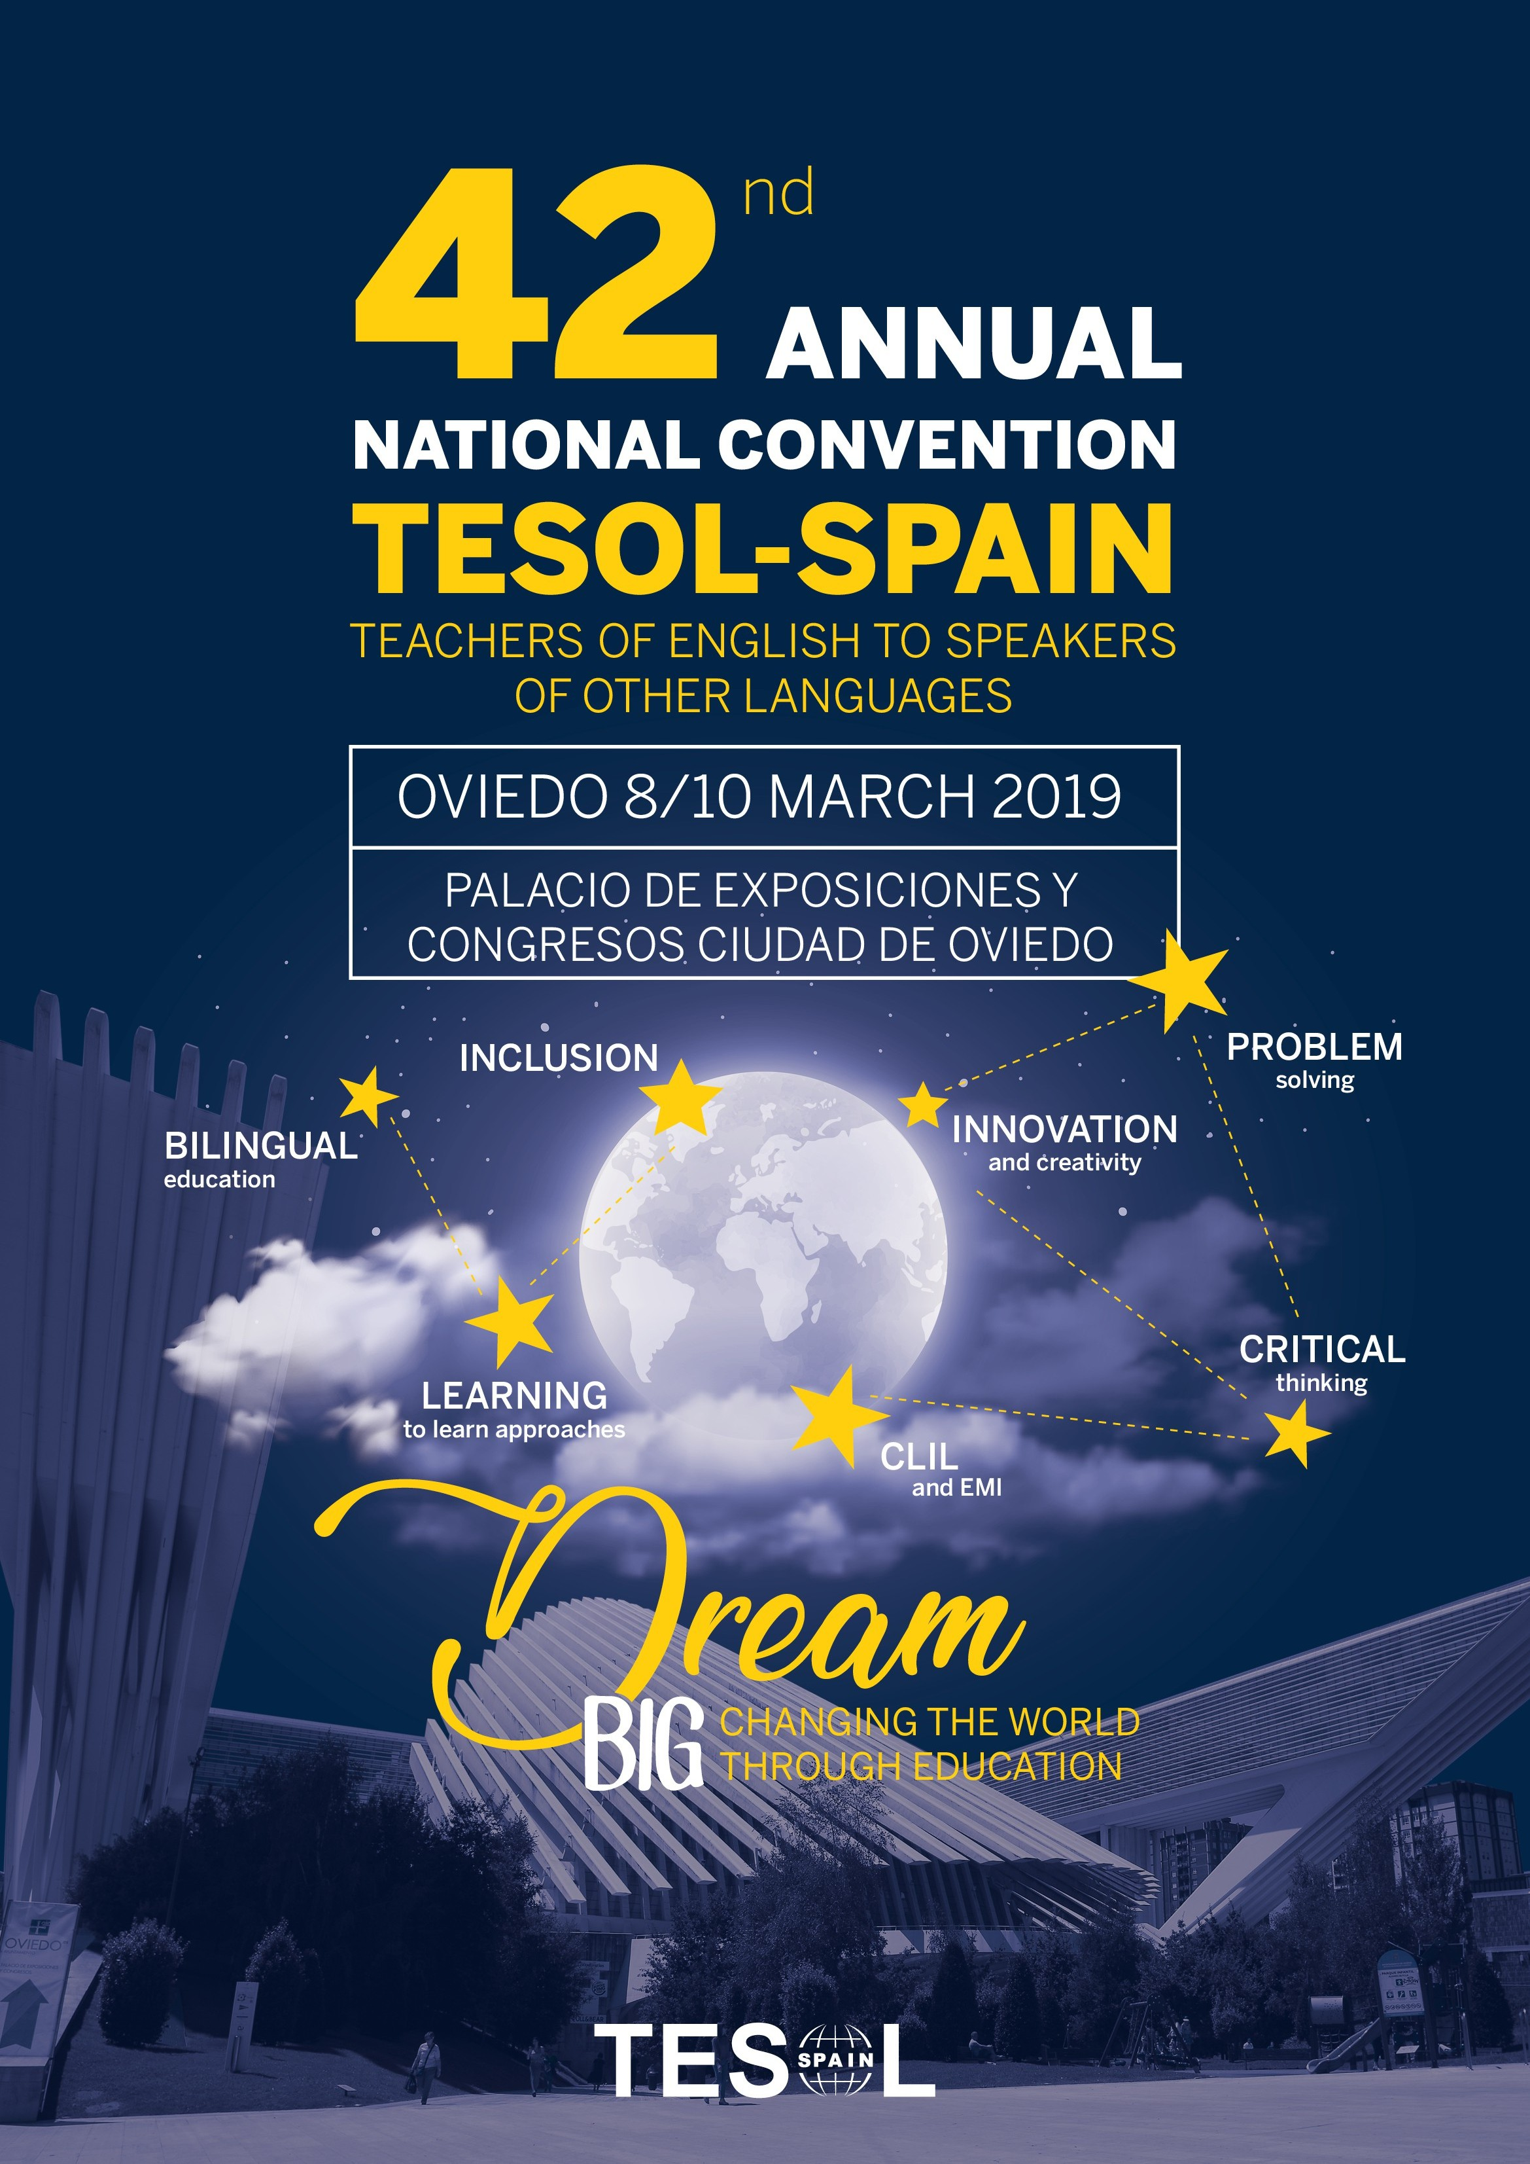

PLEASE PROVIDE THE FOLLOWING DETAILS FOR INVOICING:

General contact person: E-mail:
Company:
Person to send invoice to:
Name of person or organization invoice should be made out to:
Complete mailing address:
NIF/CIF/VAT number (there is 21% IVA/VAT on tables and advertising):

IMPORTANT

- Information on WHEN AND WHERE to send material will be facilitated one month before the Convention.

- You will be able to bring two representatives per table free of charge.
ORDER FORM
N.B. IVA/VAT is 21% (not included in the prices quoted below)
Contact person: MARIA ANTONIA CASTRO E-mail: tesol-mac@hotmail.es

TABLES | Price |  | Quantity
1 Table (1.83 x 0.76 m approximately) | €300
Unattended shared table (1/3 of a table) for printed material  i.e. brochures, leaflets, etc. | €100
DEADLINE for reserving tables | 2nd February,  2018

CONVENTION PROGRAMME ADVERTISING RATES |  | Price | Quantity
FULL COLOUR
Back cover, full page (20.7 x 29.5 cm) |  | 535,00 € | BRITISH COUNCIL
Inside front cover, full page (20.7 x 29.5 cm) |  | 505,00 € | TRINITY
Inside back cover, full page (20.7 x 29.5 cm) |  | 475,00 € | Ofrecido a SM-Silver Sp (falta confirmación)
Inside the Programme, full page (20.7 x 29.5 cm) |  | 450,00 € | ANGLIA (½ PAGE) SP  BEBC (FULL PAGE)sp  PEARSON (FULLP)SP  Aceia (½ page - free)
Middle spread (2 pages - 41.4 x 29.5 cm) |  | 1000,00 €
CONVENTION FOLDER HOLDING PROGRAMME (Full colour)
Back of folder, full page (20.7 x 29.5 cm) |  | 630,00 € | GLOBAL ELT
Inside front cover, full page (20.7 x 29.5 cm) |  | 475,00 € | Ofrecido a SM Silver Sp  (falta confirmación)
Inside sleeve, quarter page (12.5 x 16.5 cm) |  | 285,00 € | TRINITY

 | NEW!!! SPECIAL PACKAGES |  | Price |  | Quantity
 | 1 Table + 1 Advert Inside the programme full page + 1 membership |  | 600,00 €
 | 1 Table + 1 Advert Inside the programme ½ page + 1 membership |  | 500,00 €
 | 1 Table + 1 Advert inside the programme ¼ page + 1 membership |  | 400,00 €
 | DEADLINE for submitting ads |  | 18th January,  2019
2019 ANNUAL CONVENTION SPONSORSHIPS |  | Please tick the box
SPEAKER(S) (see note below*)
Welcome cocktail
Coffe break(s)
Welcome bags (with the Convention poster and the sponsor's logo) |  | ALREADY SPONSORED
Lanyards (with both the sponsor and Tesol's logo) + Plastic holders
Notebook
Pen/pencil
Mobile charging place
Meeting point
Others

We are happy to tell you that IT IS POSSIBLE to sell products on the premises.

(*) PLEASE, remember that even if the speakers do not have to pay for Convention fees, they DO have to register.

We would like to reiterate our appreciation for your support. María Antonia Castro
TESOL-SPAIN Publisher Liaison Officer

